**VIEWS**

1. **ALL PRODUCTS WITH PRICE/DISCOUNT/RATING:** (view_all_product_rating) 🡪 customer wants to view all the products along with average rating of product & discounts

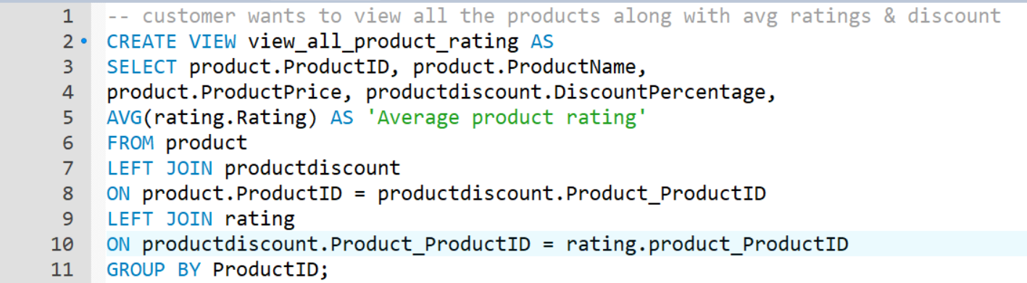

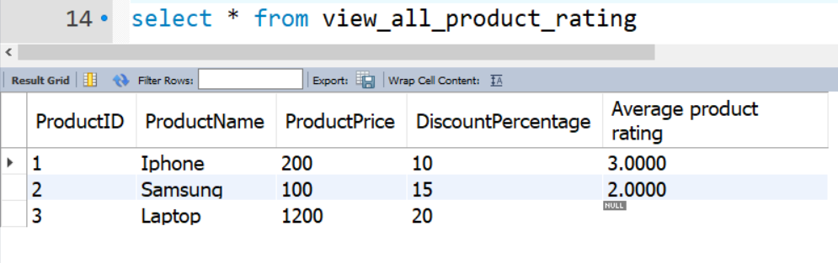

1. **MOST FREQUENTLY BUYED PRODUCTS:** (view_best_products) 🡪 View to display best products in terms of number of products sold in Purchase orders

